Landen Barber
1/11/26
Design Completion 1

Novelty Update
Since our last meeting, I have decided to fully incorporate the gyro into the core function of the controller. Alongside the gesture-based commands I’ve mentioned, it will use tilt and orientation as the primary control method to reduce reliance on fine motor control and physical buttons. Furthermore, I will incorporate adaptive assistance which will leverage continuous gyroscope input to learn user movement patterns, automatically adjusting sensitivity, filtering, and gesture thresholds over time. Making the controller more comfortable to use the longer someone uses it.
To be more specific about these points, the gesture system will use specific motions such as flicks, rotations, or even tilt to activate a distinct input command. By mapping these movements into actions, it allows those with less fine motor control to activate buttons or macros that would otherwise be difficult to press on the smaller buttons.
Adaptive assistance on the other hand will continually monitor the users’ common motions to automatically adjust the controllers’ settings. For example, softly changing gesture thresholds to ensure gestures are easily recognized and more consistently activated without the need of fine testing and applying changes in the settings menu. These types of adjustment will make the controller more convenient to use and improves the one-handed comfort of the controller.
From some more research into similar products, there are a few devices that focus on this motion-based input, called air mice. However, air mice normally are lighter handheld devices that just map motion directly to cursor movement with a few buttons, whereas my controller will include gestures and adaptive assistance to increase the number of possible actions that could be taken from movement alone.

Hardware
Thankfully This change doesn’t alter the broad design too much compared to the previous versions so many things can remain the same. To go over it once more, one of the major factors of the design is to be wireless so a few parts are used in order to achieve the desired functionality. I have a USB-C breakout board that splits the data and power lines so that they can go to separate sources while also adding USB-C compatibility. The other aspect of wireless is the use of Bluetooth, this is one of the main reasons why I chose the Nucleo-WB155CC, among other choices. While the data lines can be used by the Nucleo-WB15CC microcontroller the power lines are fed into the power boost 1000C which handles the battery connection and switching between using the battery or connected power source when needed. The battery is a 3.7v 500mWh battery which is booted to 5v by the power boost board. Another major component of this design is the ICM-20948 9-DoF IMU which includes the gyroscope, accelerometer, and MPU. This is the module that will detect the orientation and motion of the device allowing for the gesture and motion-based input. There are of course other simple components like joysticks, buttons, and haptic motors in order to fulfill other basic needs of the controller.
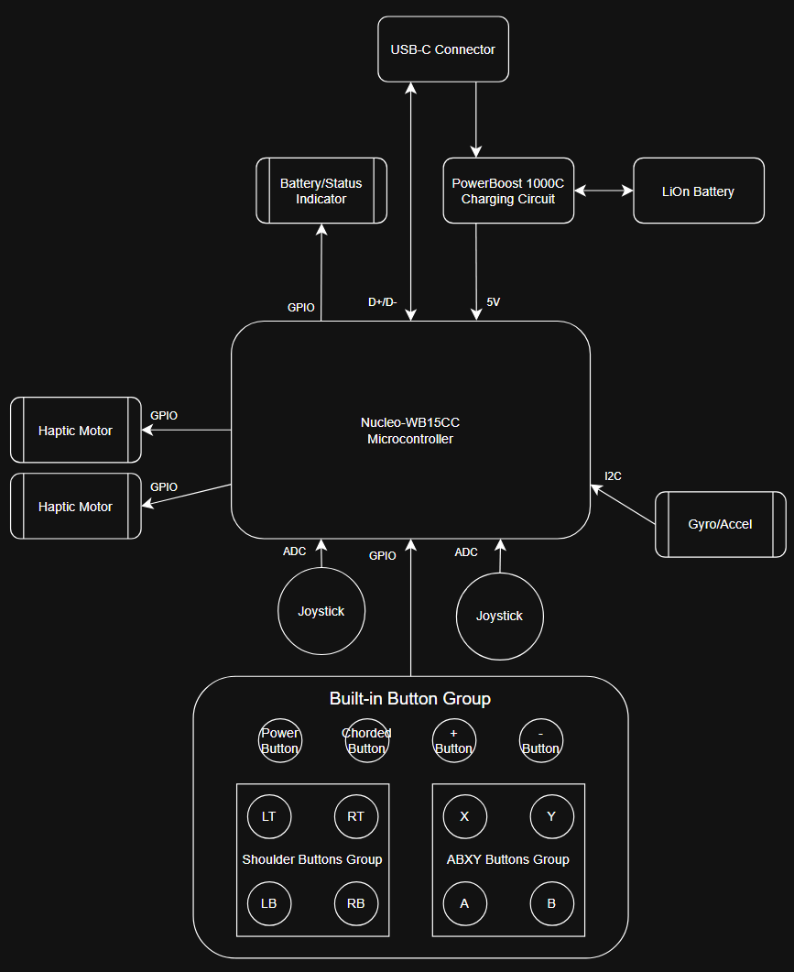
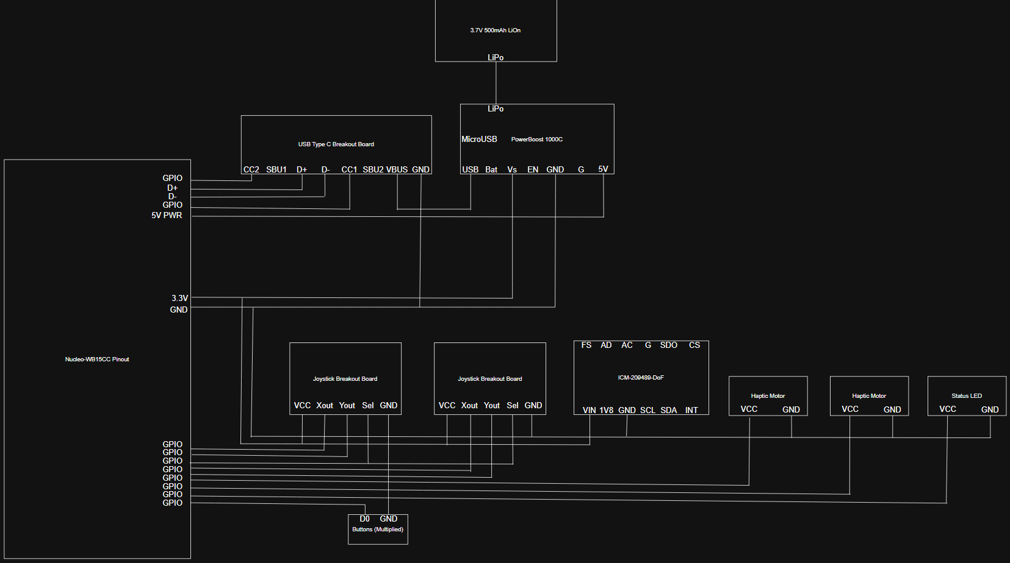

Another major aspect of the hardware side of the project tis the 3d modelling, unfortunately I have not gotten much progress done on that front. So, for now here the past drawings of what the interior components and chassis should look like generally.
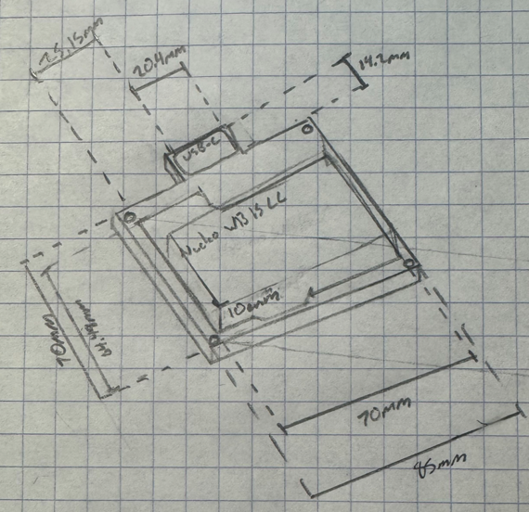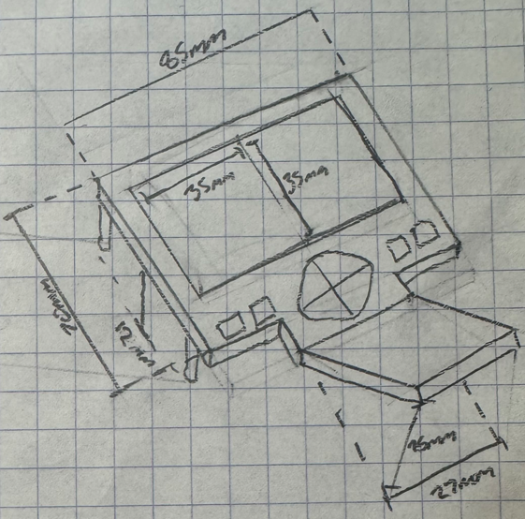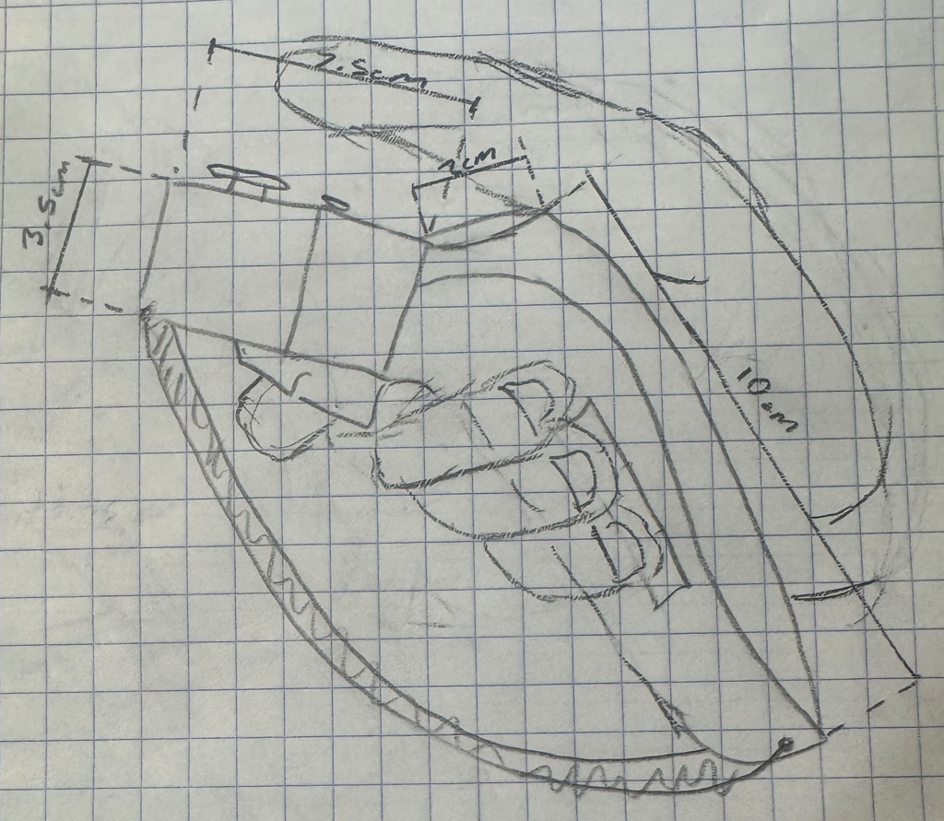

Software
The software of the controller is responsible for capturing all the users’ inputs, processing them, and converting them to outputs for a connected device. It will start by initializing the hardware components before it enters its main loop.
In this loop it will continually read data from the buttons, joysticks, and gyro where it can then take all those inputs and process them within the managers and decoder so they can easily be output to the connected device.
As the process will also handle gesture recognition in the gesture detector, it will also analyze common patterns able to detect specific movements and can be mapped to user configurable commands.
Within this process the adaptive assistance monitors movement patterns over time and automatically adjusts settings like tilt sensitivity and gesture thresholds to make the device more consistent to use for different users. This will be handled by what I called the adaptive helper.
Another feature of the controller will be its screen overlay where the user can adjust settings to change how the controller should work, as well as key binds and profiles. These settings will be stored in a database which acts as nonvolatile memory and can be changed by the adaptive helper for background adjustments. The overlay will also feature a digital keyboard that could be used to type characters.
Finally, the communications manager will determine how to transmit the output data to the connected device. It needs to have different protocols for both wired and Bluetooth connections so that it can make the best use of what is available.
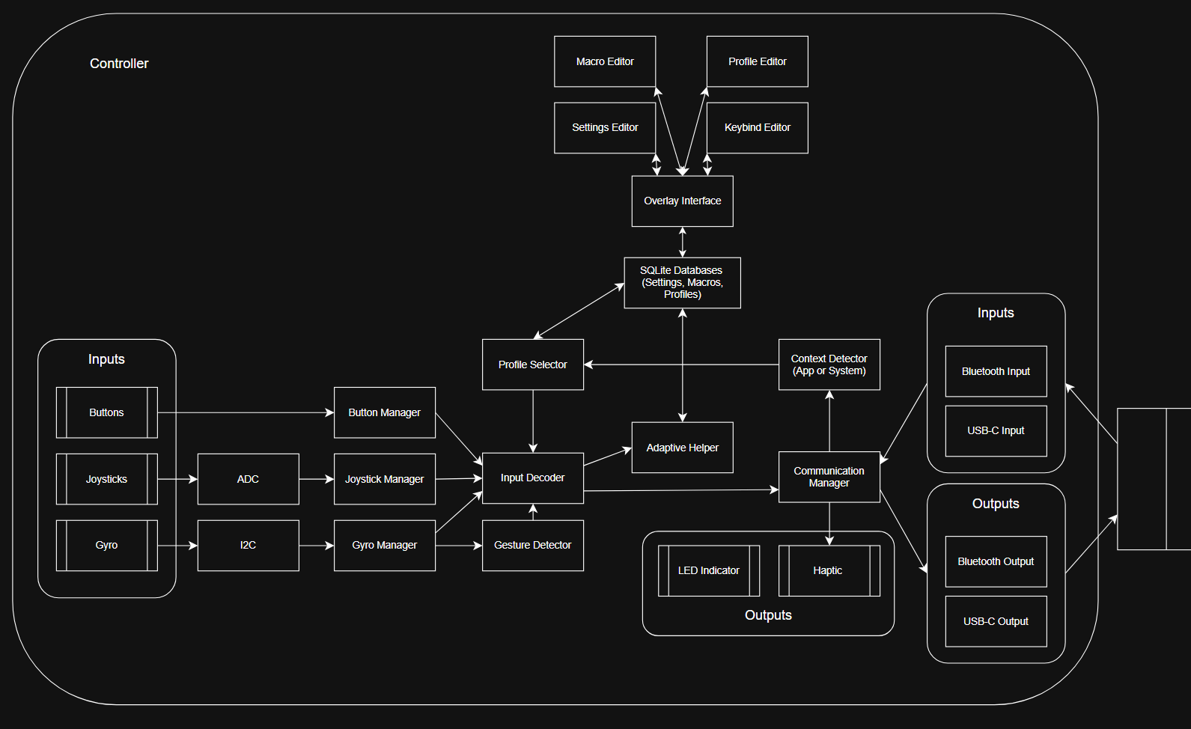

Like I mentioned last term, I will be using the STM32Cube IDE as it has latent support for my microcontroller and its onboard debugger. It will be written in C and GitHub will be used for source control and to keep a backup of all the code.
Some algorithms that will get used are ones that can smooth the movement of the gyroscope movement and add filter to remove unnecessary movement. I will also need a program that can detect sudden movements and read specific movements as gestures.

